RECEIVE AND DISPLAY REAL-TIME LOCATION, RIDERSHIP, and ARRIVAL TIME DATA

Abstract
New application and businesses are created continuously with the help of technology through the internet. IoT(Internet of Things) can assist in integration of communication, control and information processing across various transportation systems. In public transportation, there is lack of real time information. The public transit usage can be improved if real time information of the vehicle such as the seating availability, current location and time taken to reach the destination are provided with easier access. It would also be helpful for the passengers to find alternate choices depending on their circumstances. As excessive long waiting often discourage the travelers and makes them reluctant to take buses. A smart information system has been proposed where the travelers get prior information about current location, next location of bus and crowd level inside the bus. This system is designed using ARDUINO UNO, IR Sensor and GPS Module. An Intelligent Transport System (ITS) removes the barriers for public transport usage and creates the positive impact about the bus journey.
In recent years, smart public transportation has become one of the most important things for developing cities and improving people’s quality of life. Public transportation users face many problems, the most important of which is the long wait at the bus station.

INTRODUCTION
Public transport is a service available on sharing basis for the benefit of general public. It includes city buses, trolleybuses, trams, passenger trains, ferries and rapid transit like metro and subways. Unlike transportation modes like carpooling, rickshaws and taxis, this system encompasses an entirety of strangers.

The main reason why the people choose public transportation over other modes of transport are its subsidized rates, environment-friendly attributes and easy accessibility. Firstly, public transport is very economical allowing a large population to have access to it. Using a bus or a train to commute is comparatively cheaper than using a private car. If people have their own car, they have to spend a lot of money on fuel, car servicing, repairs, and insurance. There are many discounts available for some individuals, like students and senior citizens who choose public transport as their transportation option to get to work or to school. Secondly, public transport can preserve the environment by reducing the amount of pollution. With an increase in the use of public transportation, there will be a reasonable dip in the number of private vehicles on the road, therefore, improving the environment and in addition, solving the traffic congestion issue[10]. Furthermore, public transportation has good accessibility in big cities, making it easier to travel to any part of the city, making buses a favorable option. It provides personal mobility and freedom for people.

Taking into consideration the other aspects of public transportation, there are some downsides to this service as well. Public transportation, by its very nature, is far more time consuming than any other mode of transportation. Most trains and buses run in accordance with a scheduled timetable. However, these time schedules are seldom followed. There is always an uncertainty regarding the arrival of a bus. Often, buses break down causing further problem to commuters. Another pitfall we see is that public transportation often lacks organization. Commuters are often confused with regards to bus routes and bus stops. Even if the buses are running on time, they are usually crowded, the reason- being, less frequency of the buses. Since the ratio of the buses to the population availing public transportation is disproportionate, overcrowded buses are not a rare sight In public transportation, there is lack of information about the arrival time. Along with the uncertainty in time, there is also an apprehension regarding the capacity of a bus.

Even if the passenger is aware about the arrival time of the bus, they do not know how many additional people can be accommodated inside the bus. The information will be half-baked and hence of no use. Thus, determining capacity of any given bus is equally important to the arrival time estimation. Thus, the system will eradicate the uncertainty in arrival time that commuters face every day and prove to be of great assistance in planning their journeys well in advance. As excessive long waiting often discourage the travelers and makes them reluctant to take buses. With regard to all the problems mentioned above, the simple knowledge of bus related information can solve a number of discrepancies related to public transportation.

For instance, the time of arrival and departure of each bus, a comprehensive list of bus-stops, etc. can prove to be very beneficial. The opportunities to improve existing public bus transportation by embedding advanced technology into real time transport system is provided by internet of things. Internet of things is inter-networking of physical devices with electronics and network connectivity that control these objects to collect and exchange data. IoT is not only used to sense the information but also to interact with the physical world. IoT can assist in integration of communication, control and information processing across various transportation systems. Internet of things is used to provide Interaction between the passenger and bus by means of internet.

PROPOSED SYSTEM
In this paper we present the smart information system shown in figure 1 which will allow the travelers to take alternative transport choice by providing information about location of the bus and crowd level inside the bus.
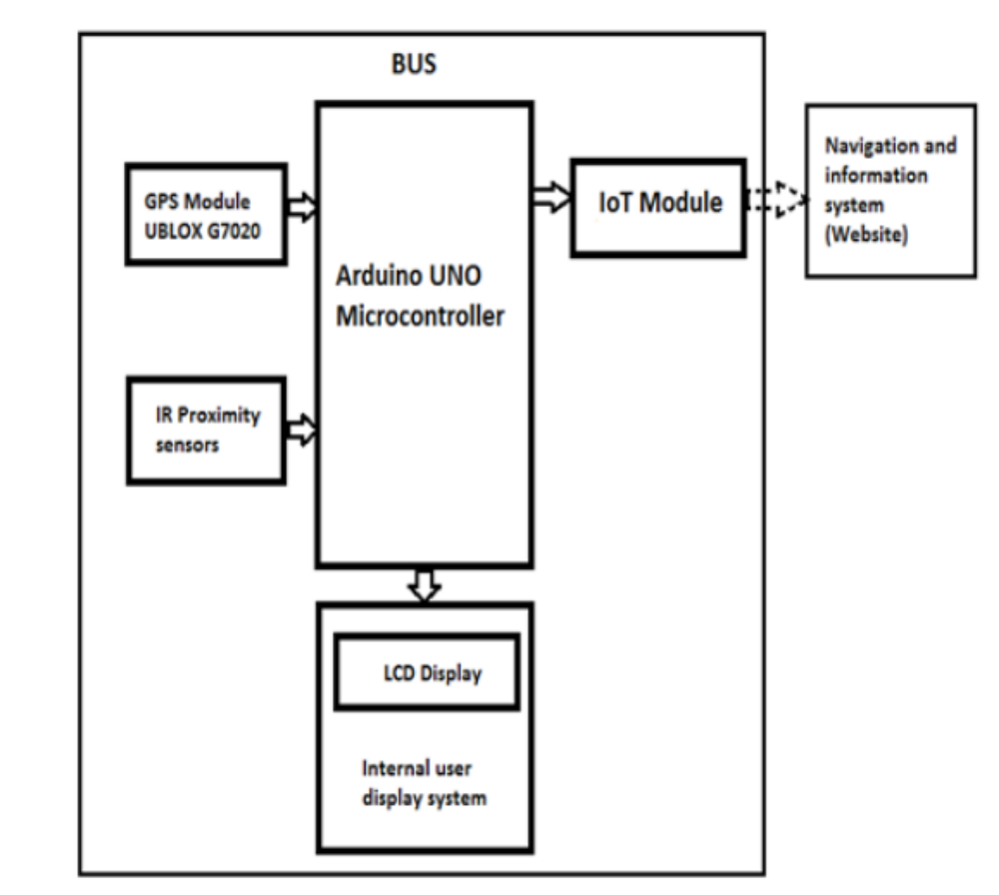

The vital components of smart information system are micro-controller, IR proximity sensor, GPS Module, IoT Module. Inside the bus, GPS module and four IR proximity sensors are used.

Two IR sensors are kept at entry path and another two kept at exit path. IR Proximity Sensor is used to count the number of persons inside the bus. GPS Module is used to find the latitude and longitude of current location of the bus. Information from sensors and GPS module is sent to Controller and via IoT module information will be displayed in webpage IoT Module is used to establish communication between controller and webpage. For the passengers inside the bus the current stop, next stop and approximate time to reach next stop will be displayed in LCD Display which is fitted inside the bus. And for the persons outside the bus, the information about the current location of the bus and number of passengers inside the bus will be provided through webpage. The information will be given to outside passengers only if they access the webpage.

If crowd level is determined using MAC address, persons who are not having smart phones are not taken into account .And if we use limit switch to count number of person, it will count the seated passengers. Passengers who are standing are not taken into accounts we using IR sensors in both entry and exit path to detect the crowd level .While tracking the location using smartphones, we need to have at least one smartphone inside the bus and if the battery is drained in smart phone, there is no alternate choice to locate the bus.So, the GPS module ubloxG7020 is fitted with every bus to know the current location of the bus.

Distance Calculation

The Haversine formula was adopted to calculate the distance that will appear in the Android app. It calculates the distance between the passenger and the bus location using the latitude and longitude of the bus and the passenger who is at home, work, or at the bus stop. The following equations can be used to calculate the distance

a=sin2(Δφ/2)+cosφ1?cosφ2?sin2(Δλ/2)
c=2?atan2(a?1?a)
d=R?c

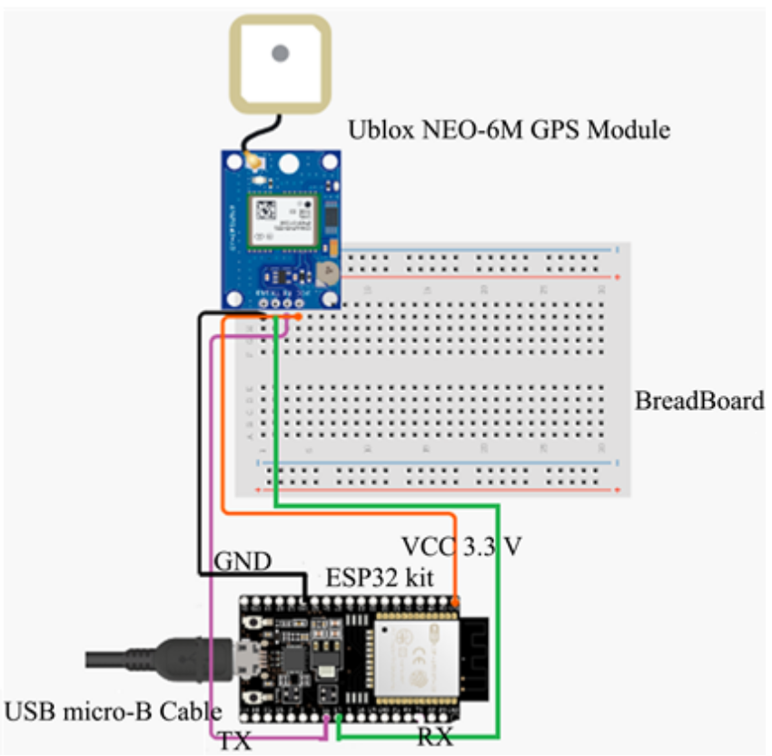

The arrival time of each bus, which will appear in the Android app, is calculated based on the following equation.

t=d/s*60

where: t = arrival time of bus.
d = distance between the passenger and bus location that get from Equation (3).
s = average speed of bus along route.
To convert the arrival time (t) that will be obtained from Equation (3) from an hour into a minute, it is multiplied by 60

Bus location prediction

To detect current location of vehicle GPS is used to interpret the coordinates of the vehicle. A microcontroller embedded with GPS is used to track the location of the bus. A GPS navigation device or GPS receiver is used for vehicle navigation. It is the device that is capable of receiving information from GPS Satellites and then to accurately calculate its geographical location. It can retrieve from the GPS System Location and Time information in all-weather conditions, anywhere on earth. A GPS reception requires an unobstructed line of sight to 4 or more GPS satellites.

The location details such as latitude and longitude are received through GPS module through the embedded system. The system is programmed with a route map which enables us to identify the location. The entire route’s is latitude and longitudes are stored in the system with corresponding stops that need to be taken. When the bus is moving the GPS module stays active and sends the tracking data to the controller. The controllers compress the real time data with logged in data to identify the current location and the stops. When the vehicle reaches the stop the system automatically detect the corresponding and displays the stop information to the users.

For location prediction, GPS Module is used. In our project, we have taken five fixed stops. They are Stop1: SRIT Parking, STOP2: SRIT Entrance, STOP3: Pachapalayam, STOP4: Chettipalayam, STOP5:Perur.First the latitude and longitude readings of the above 5 places are noted and then those values are fed into program. When the bus moves the GPS module which is kept inside the bus sends the latitude and longitude of the current location of the bus.

Arduino compares those values with the already available values and display the name of the current location if the values match or else simply displays latitude and longitude of that place. The flowchart for the bus location identification when the bus moves from SRIT Parking to Perur is shown below in the figure 3.The procedure remains same when the bus starts from Perur and ends in SRIT Parking. But, the small modification should be done to display next location and arrival time.

Distance Accuracy Analysis

the distance level, the accuracy obtained through the calculation of the great circle distance equation, and the comparison between the total distance obtained from each of the test data and the total distance through real distance.

The Haversine equation used to measure the accuracy of the obtained distance. Based on a study of 4 days with different times, the average difference between the calculated values computed by the Haversine equation compared to the data obtained from a real distance is (177 meters) with an error ratio between 8 to 225 meters. This error is due to the fact that the Haversine equation

calculates the distance between two points on the surface of the Earth, assuming that the geometry of the earth is completely spherical (ignoring ellipsoidal effects) with a mean radius of 6.371 Km. Since the earth is not spherical, the earth in reality is elliptical with a radius between 6.378 Km (equatorial) and 6.357 Km (polar). This means the errors from assuming spherical geometry may reach 0.55%.

Conclusion

This paper introduces a prototype of a smart public transport system that is designed and implemented using IoT technology, GPS, and ESP32

A smart information system is presented for the bus passengers that have the ability to interconnect passengers with real-world public bus. The Smart information system based on distributed IoT System consists of IR Sensors, GPS Module, Arduino UNO, and IoT Module to count the number of passengers and to provide information about current and next location of the bus. Since the users are provided with real time information about the vacant seats, the passengers will able to take better decisions in terms of which bus they would take.

